Test Plan

#### Component Name: AlgorithmButton

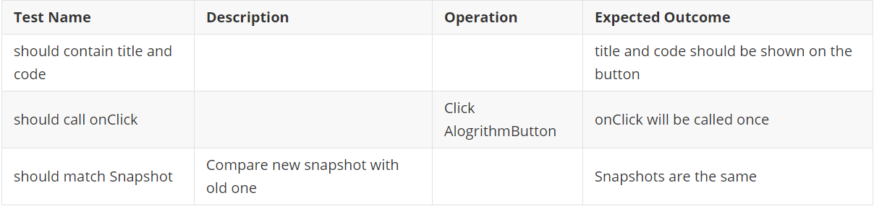

#### Component Name: AnimationControl

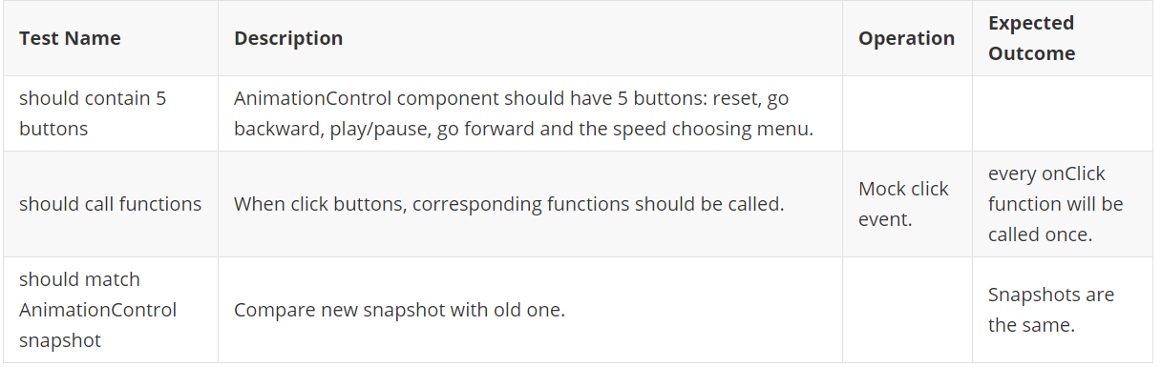

#### Component Name: AnimationSlider

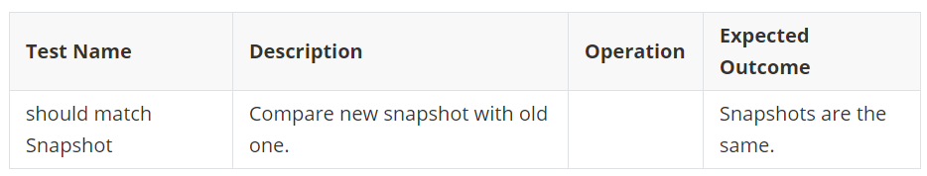

#### Component Name: AnimationWithCode

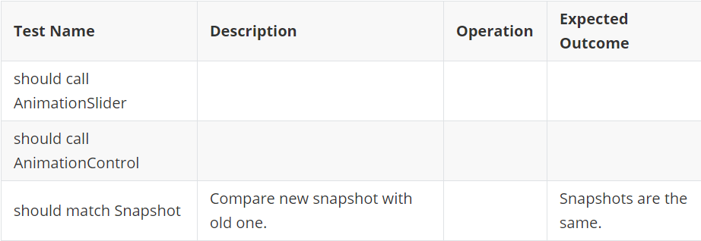

#### Component Name: CorrectnessHelp

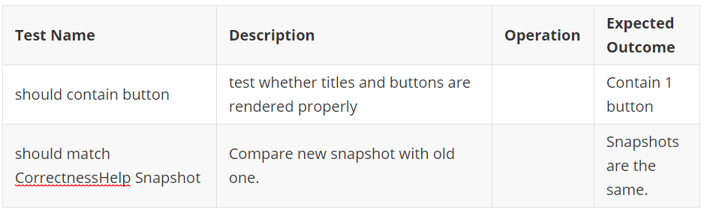

#### Component Name: ExplanationBox

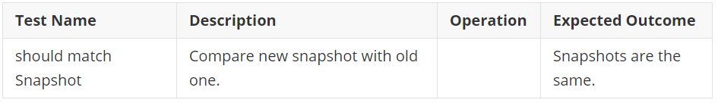

#### Component Name: FirstInBackdrop

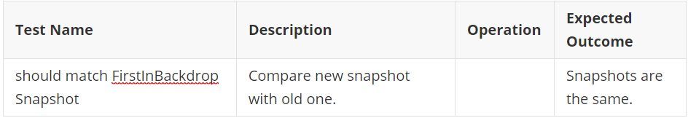

#### Component Name: InputBar

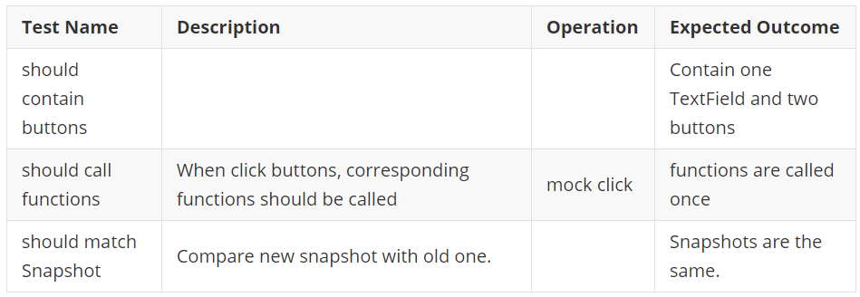

#### Component Name: InputTable

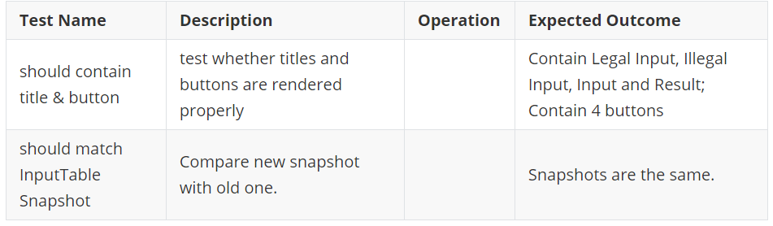

#### Component Name: Module

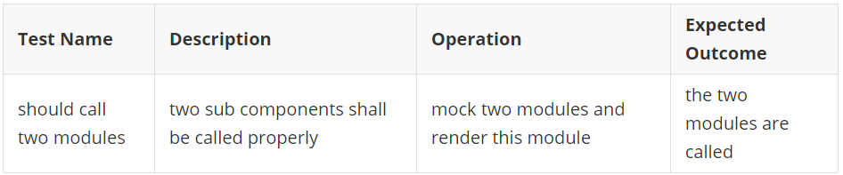

#### Component Name: ModuleButton

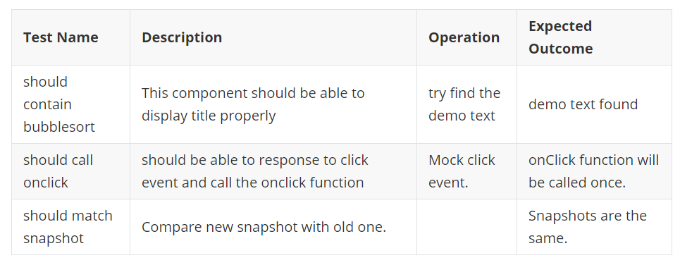

#### Component Name: ModuleProgress

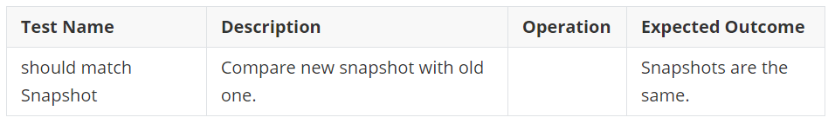

#### Component Name: Implementation

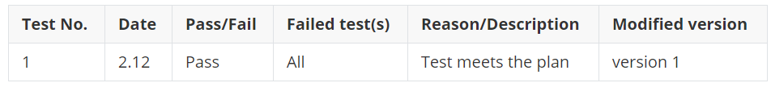

#### Component Name: ProcedureOperation

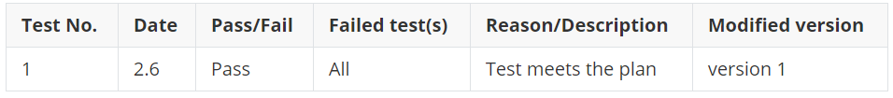

#### Component Name: SpeedMenu

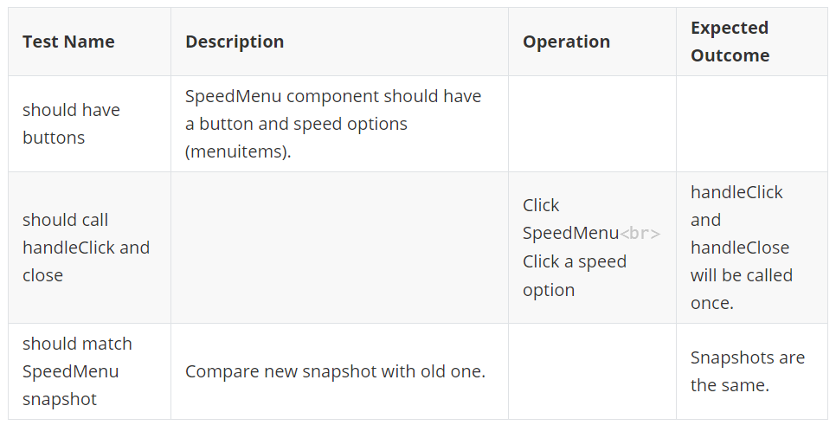

#### Component Name: SwitchAnimation

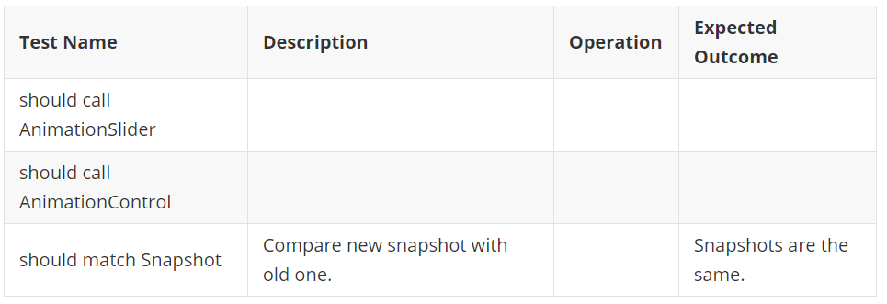

#### Component Name: TickCross

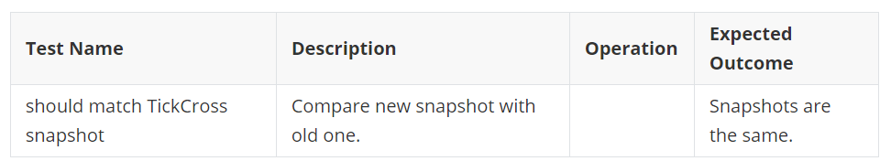

#### Component Name: TipFrame

